HI-MACS® launches its Lucia collection with three new colours by Marcel Wanders
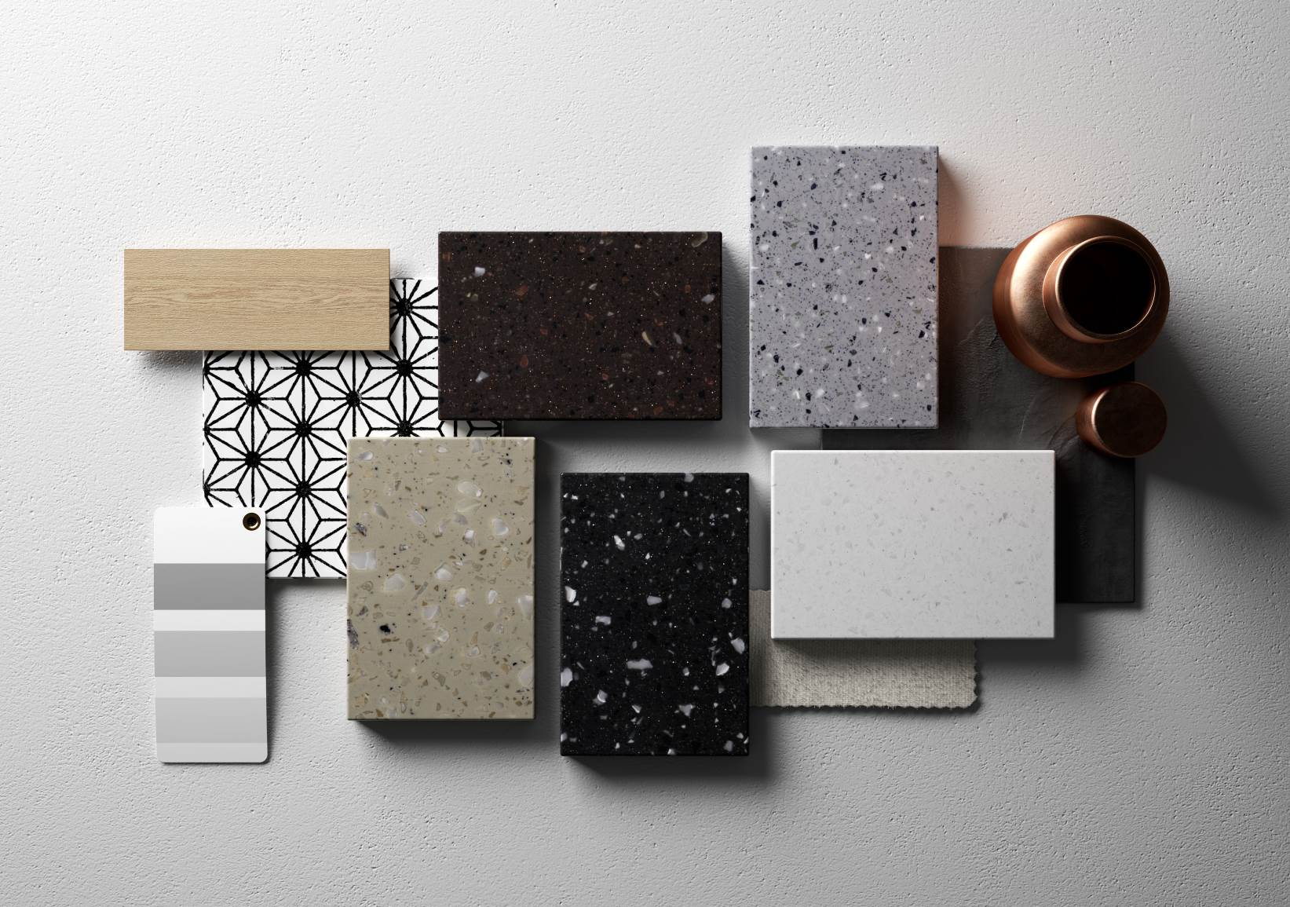

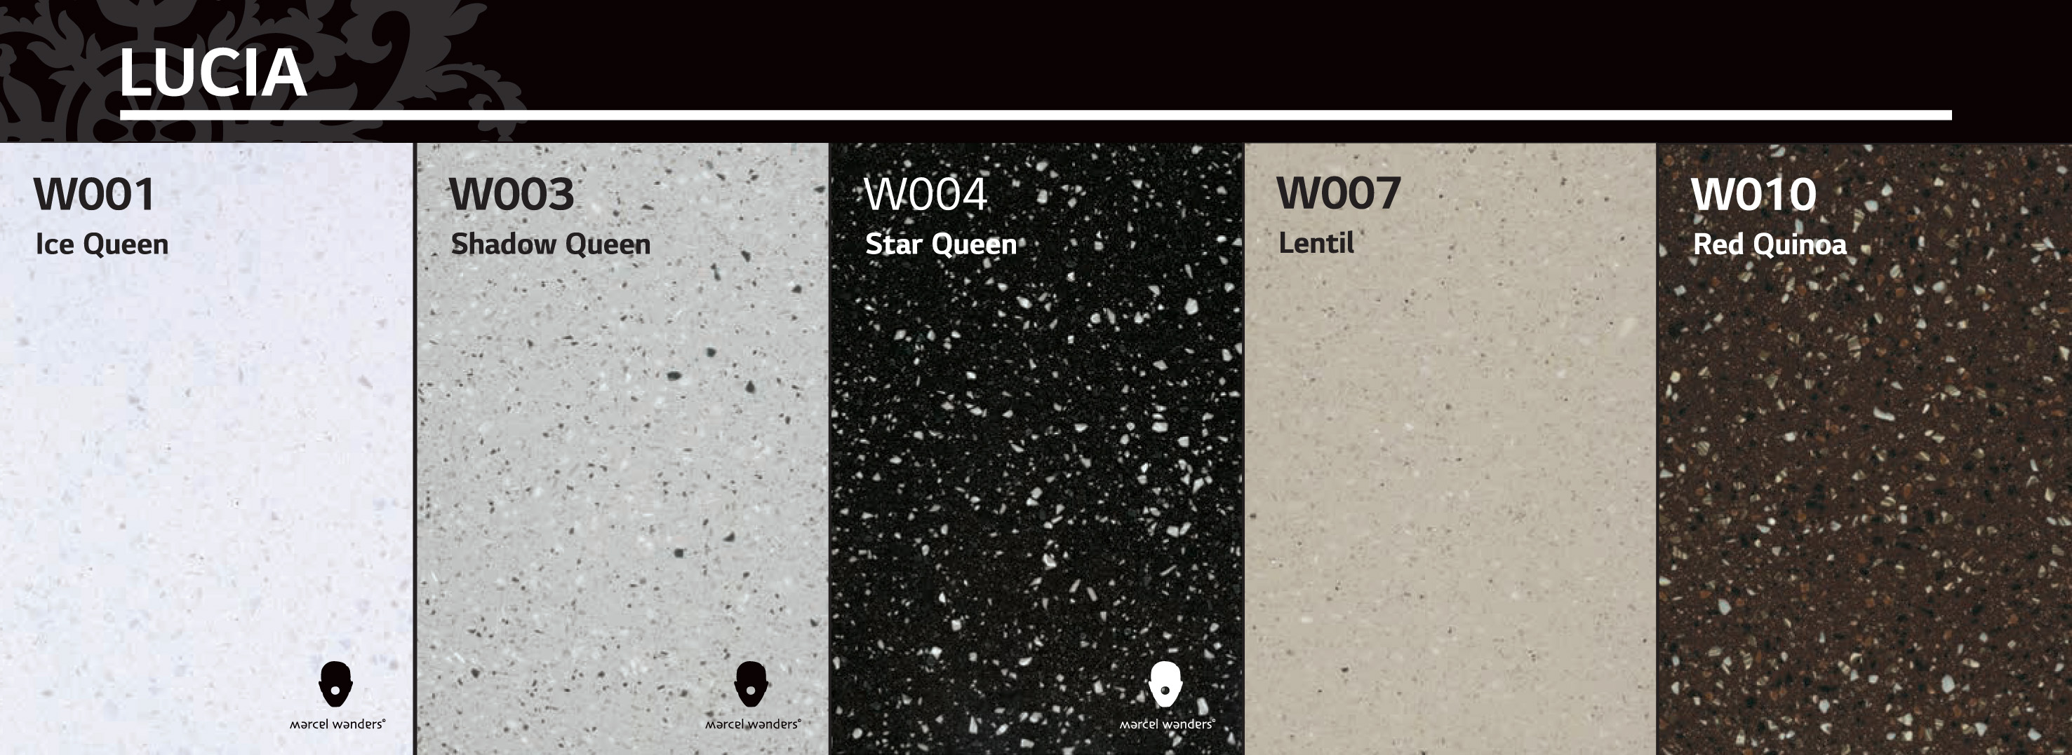

HI-MACS® launches its new 2016 colours: the LUCIA collection. After the success of the collaboration for Milan Design Week 2015 with Dutch designer Marcel Wanders, LG Hausys launches three new colours of the new collection by the famous designer: Ice Queen, Shadow Queen and Star Queen.
Presented as a sneak preview at BATIMAT tradeshow in Paris, the LUCIA collection for HI-MACS® is a subtle combination of the depth of the material with playful tone-on-tone colours. The depth seen in the substance is accomplished by inlaying particles that bring out its organic appearance and create warm inner spaces.
This new range includes five colours - Ice Queen, Shadow Queen and Star Queen created by Marcel Wanders plus Lentil and Red Quinoa - and gives the world of design and architecture the freedom to create increasingly voluptuous, sensuous projects that people never tire of touching and admiring. With LUCIA, HI-MACS® “solid surface” retains all of its unparalleled qualities: versatile, thermoformable, durable, invisible joints, waterproof and hygienic.
Loaded with character, the three tones created by Marcel Wanders, work with powerful contrasts. In essence, they reflect poetic notes evocative of moonlight flickering on dark, deep waters, sunlight sparkling on crystalline ice, and the misty tones of mysterious moonscapes.
“I am excited about all the possibilities these new colours allow. We named them after poetic characters full of personality: ‘Star Queen’ ‘Ice Queen’ and ‘Shadow Queen’. In their company you are free to explore a world of polarities: dark versus light, black versus white and the grey spectrum in between”. - Marcel Wanders
Marcel Wanders’ luminous textures vary from opaque to translucent and are a subtle blend of microparticles and coarser shavings which give them an intense luminosity.
Marcel Wanders’ three new colours harmoniously complement the Lucia collection’s Lentil and Red Quinoa, whose shades provide equal contrast and warmth.
The LUCIA collection is available in Europe as of 1° January 2016, enhancing the broad range of colours, effects and textures that have made HI-MACS® an exceptional material, which can be used in a myriad of ways.
For more information visit www.himacs.eu

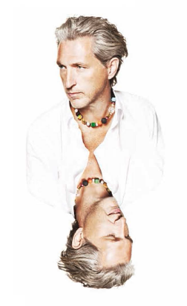
Marcel Wanders
Marcel Wanders (Boxtel, Netherlands, 1963) is a prolific product and interior designer and art director, with over 1700+ projects to his name for private clients and premium brands such as Alessi, Bisazza, Kosé Corporation/Cosme Decorte, KLM, Flos, Swarovski, Puma, among scores of others. In 2001 Marcel co-founded the successful design label Moooi, of which he is also Art Director.
Regarded by many as an anomaly in the design world, Marcel has made it his mission to “create an environment of love, live with passion and make our most exciting dreams come true.” His work excites, provokes, and polarises, but never fails to surprise for its ingenuity, daring and singular quest to uplift the human spirit, and entertain.
Marcel’s chief concern is bringing the human touch back to design, ushering in what he calls design’s ‘new age’; in which designer, craftsperson and user are reunited. In his process, Marcel defies design dogma, preferring instead to focus on holistic solutions rather than the technocratic. In Marcel’s universe, the coldness of industrialism is replaced by the poetry, fantasy and romance of different ages, vividly brought to life in the contemporary moment.
www.marcelwanders.com

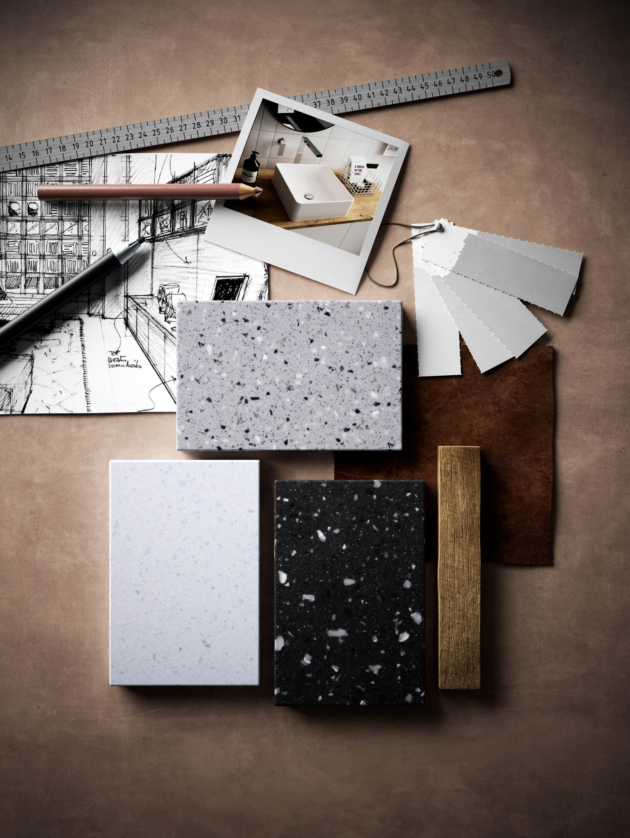

HI-MACS® by LG Hausys
^{www.himacs.eu}
HI-MACS® is a solid surface material that can be moulded into any shape. It is widely used for architectural and interior applications, such as sculptural and high performance wall-cladding or kitchen, bathroom and furniture surfaces, in commercial, residential and public space projects. It is composed of acrylic, natural minerals and pigments that come together to provide a smooth, non-porous and visually seamless surface which meets the highest standards for aesthetics, fabrication, functionality and hygiene – offering manifold advantages over conventional materials.
HI-MACS® provides limitless possibilities for surfacing solutions and inspires creative minds from all over the world. Zaha Hadid, Jean Nouvel, Rafael Moneo, Karim Rashid and David Chipperfield, among others, have completed fabulous projects using HI-MACS®, from kitchens to bathrooms, including decorative items, in hotels as well as in museums, shopping centres and on external façades.
LG Hausys’ HI-MACS® uses a simple heating process to give three-dimensional thermoplastic forming capabilities, allows visually seamless designs, offers a virtually limitless range of colours and – for some shades - exhibits a special translucency when exposed to light. Although HI-MACS® is almost as robust as stone, it can be worked in a similar way as wood: it can be sawn, routed, drilled or sanded.
HI-MACS® is manufactured using a new generation technology, the thermal cure. The temperature reached during the manufacturing process sets HI-MACS® apart from other solid surfaces and creates a denser, even more homogeneous, sturdy, durable surface – with a better resistance and superior thermoforming performance.
As regards hygiene, HI-MACS® does not absorb humidity, is highly resistant to stains, and is easy to clean, maintain and repair.
Countless internationally recognized certificates attest to the quality of HI-MACS® in terms of ecological commitment, hygiene and fire resistance – being the first Solid Surface in the market to receive the official European Technical Approval (ETA) for façades – for Alpine White S728 colour.
HI-MACS® offers the longest warranty on the solid surface market with a 15-year warranty for products fabricated by a Quality Club Member.
HI-MACS® The New Generation
Inspired by Architecture
For more information and to stay connected, visit our website and our newsroom.
Let’s connect!
* HI-MACS® is designed and produced by LG HAUSYS, a world leader in the technology sector belonging to LG Group, and distributed by LG HAUSYS EUROPE based in Geneva (Switzerland).

